EXPERIMENT 23
Deploy a Multi-Container Application Using Kubernetes

AIM
To deploy a multi-container application consisting of a frontend, backend, and database using Kubernetes, monitor the Pods and Services, expose the application, and scale the frontend to handle increased load.

THEORY
Kubernetes is a container orchestration platform used to automate the deployment, scaling, networking, and management of containerized applications. A multi-container application can separate the user interface, backend API, and database into independent workloads. Kubernetes Deployments maintain the desired number of Pods, while Services provide stable networking between components and external access. Scaling a Deployment increases the number of Pods available to handle additional traffic.

PROCEDURE
- Create the frontend application and its Dockerfile.
- Create the backend API application and its Dockerfile.
- Configure the database component and its required image/configuration.
- Create Kubernetes Deployment YAML files for frontend, backend, and database.
- Create Kubernetes Service YAML files for the application components.
- Apply the Kubernetes YAML configuration using kubectl apply -f.
- Verify the deployed Pods using kubectl get pods.
- Verify the Services using kubectl get svc.
- Access the frontend application through its exposed NodePort.
- Scale the frontend Deployment using kubectl scale deployment/frontend --replicas=4.
- Verify that four frontend Pods are running.
- Open the Kubernetes Dashboard and monitor the workloads and Pods.

IMPLEMENTATION
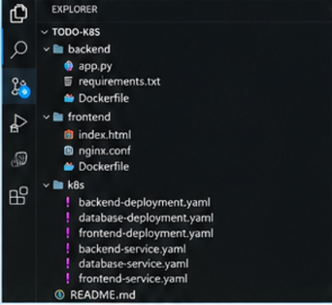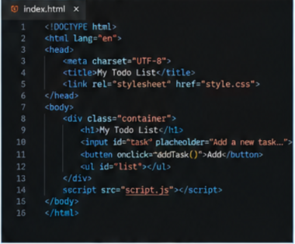
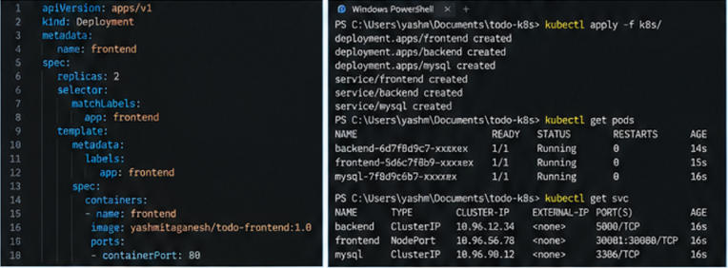
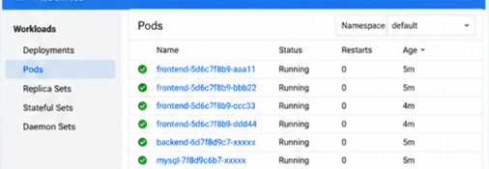
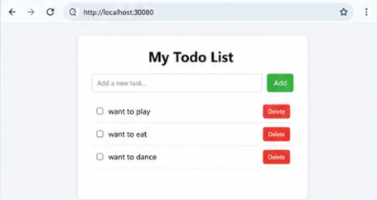

IMPLEMENTATION DETAILS
Parameter | Value
Frontend | HTML/CSS/JavaScript application
Backend | Python Flask API
Database | MySQL
Orchestration | Kubernetes
Frontend Service | NodePort
Frontend NodePort | 30080
Initial Frontend Replicas | 2
Scaled Frontend Replicas | 4
Verification | kubectl get pods / kubectl get svc
Monitoring | Kubernetes Dashboard

KUBERNETES COMMANDS USED
kubectl apply -f k8s/
kubectl get pods
kubectl get svc
kubectl scale deployment/frontend --replicas=4
kubectl get pods
kubectl get deployments
kubectl get svc

OUTPUT
The frontend, backend, and database components were successfully deployed as Kubernetes workloads. The Pods and Services were verified using kubectl. The frontend application was accessed through the NodePort, and the frontend Deployment was scaled to four replicas. The Kubernetes Dashboard displayed the running workloads and Pods.

RESULT
Thus, the multi-container application was successfully deployed, monitored, exposed, and scaled using Kubernetes.

CONCLUSION
The experiment demonstrates Kubernetes-based orchestration of independent application components, service-based networking, workload monitoring, and horizontal scaling of the frontend.

SCREENSHOT NOTE
The implementation figure is provided in a lab-record format showing the complete deployment workflow, including source structure, Kubernetes YAML, kubectl verification, scaling, dashboard monitoring, and application output.

